**Experiment -8**

|  |  |
| --- | --- |
| **Student Name: Aditi R Sinha**  **UID: 22BCS15130**  **Branch: BE-CSE**  **Semester:6th**  **Subject Name: Project-Based Learning in Java with Lab** | **Section/Group: KRG 2B**  **Date of Performance:17/03/2025**  **Subject Code: 22CSH-359** |

**Aim:** To develop a servlet that accepts user credentials from an HTML form and displays a personalized welcome message on successful login.

**Objective:** Learn form handling with Servlets

Understand HTTP request/response handling Practice doPost() method

**Code:**

<!DOCTYPE html>

<html>

<head><title>Login</title></head>

<body>

<form action="LoginServlet" method="post">

Username: <input type="text" name="username"><br>

Password: <input type="password" name="password"><br>

<input type="submit" value="Login">

</form>

</body> </html>

import java.io.*; import javax.servlet.*; import javax.servlet.http.*;

public class LoginServlet extends HttpServlet { protected void doPost(HttpServletRequest request, HttpServletResponse response) throws ServletException, IOException {

String user = request.getParameter("username");

String pass = request.getParameter("password");

response.setContentType("text/html"); PrintWriter out = response.getWriter(); if ("admin".equals(user) && "1234".equals(pass)) { out.println("<h2>Welcome, " + user + "!</h2>");

} else { out.println("<h2>Login Failed. Invalid credentials.</h2>");

}

}

}

<web-app>

<servlet>

<servlet-name>LoginServlet</servlet-name>

<servlet-class>LoginServlet</servlet-class>

</servlet>

<servlet-mapping>

<servlet-name>LoginServlet</servlet-name>

<url-pattern>/LoginServlet</url-pattern>

</servlet-mapping>

</web-app>

**Output:**

1)

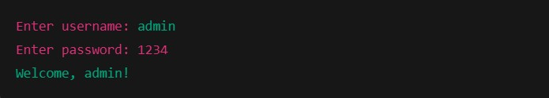

2)

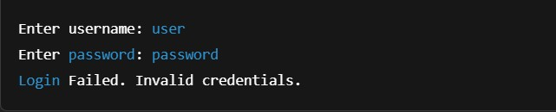

**Experiment -8.2**

**Aim:** To build a servlet integrated with JDBC that displays all employees and enables search by employeeID.

**Objective**: 1) Use JDBC with Servlet

1. Fetch and display records
2. Implement search functionality

**Code:**

<!DOCTYPE html>

<html>

<head><title>Search Employee</title></head>

<body>

<form action="EmployeeServlet" method="post">

Enter Employee ID: <input type="text" name="empId">

<input type="submit" value="Search">

</form>

</body>

</html>

import java.io.*; import javax.servlet.*; import javax.servlet.http.*; import java.sql.*;

public class EmployeeServlet extends HttpServlet { protected void doPost(HttpServletRequest request, HttpServletResponse response) throws ServletException, IOException {

String empId = request.getParameter("empId"); response.setContentType("text/html"); PrintWriter out = response.getWriter();

try {

Class.forName("com.mysql.jdbc.Driver");

Connection con =

DriverManager.getConnection("jdbc:mysql://localhost:3306/company", "root", "password"); String query = "SELECT * FROM employees WHERE emp_id=?";

PreparedStatement ps = con.prepareStatement(query); ps.setString(1, empId);

ResultSet rs = ps.executeQuery();

if (rs.next()) { out.println("<h2>Employee Details</h2>"); out.println("ID: " + rs.getInt(1) + "<br>"); out.println("Name: " + rs.getString(2) + "<br>"); out.println("Department: " + rs.getString(3));

} else { out.println("No employee found with ID " + empId);

}

con.close();

} catch (Exception e) { out.println("Error: " + e.getMessage()); }

}

}

**Output:**

1)

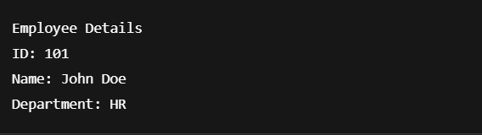

2)



**Experiment -8.3**

**Aim:** To develop a JSP-based student portal that accepts attendance data and saves it to the database using a servlet.

**Objective:** 1) Combine JSP for UI and Servlets for logic

1. Perform INSERT using JDBC
2. Build a real-world web flow **Code:**

<%@ page language="java" %>

<html>

<head><title>Student Attendance</title></head>

<body>

<h2>Mark Attendance</h2>

<form action="AttendanceServlet" method="post"> Roll No: <input type="text" name="roll"><br> Name: <input type="text" name="name"><br> Status: <select name="status">

<option>Present</option>

<option>Absent</option>

</select><br>

<input type="submit" value="Submit">

</form>

</body> </html>

import java.io.*; import javax.servlet.*; import javax.servlet.http.*; import java.sql.*;

public class AttendanceServlet extends HttpServlet { protected void doPost(HttpServletRequest request, HttpServletResponse response) throws ServletException, IOException {

String roll = request.getParameter("roll"); String name = request.getParameter("name"); String status

= request.getParameter("status"); response.setContentType("text/html"); PrintWriter out = response.getWriter();

try {

Class.forName("com.mysql.jdbc.Driver");

Connection con =

DriverManager.getConnection("jdbc:mysql://localhost:3306/student_portal", "root", "password");

String query = "INSERT INTO attendance (roll_no, name, status) VALUES (?, ?,

?)";

PreparedStatement ps = con.prepareStatement(query); ps.setString(1, roll);

ps.setString(2, name); ps.setString(3, status);

int i = ps.executeUpdate(); if

(i > 0) { out.println("<h3>Attendance marked successfully for " + name + "!</h3>"); }

con.close();

} catch (Exception e) { out.println("Error: " + e.getMessage()); }

}

}

CREATE TABLE attendance ( id INT AUTO_INCREMENT PRIMARY KEY,

roll_no VARCHAR(20), name VARCHAR(100), status VARCHAR(10)

);

**OUTPUT:**

